**Anypoint Access Management**

-Creating organisation, adding users and their access roles.

**Anypoint Security**

-Policies

-Secrets Manager

-Tokenization Service

**API Manager :**

-API Manager can track the API throughout the life cycle as you modify, version, deploy, govern, and publish it

-Design Center for creating the RAML structure of the API

-Exchange for storing and publishing API assets

-Studio for implementing the API

**Compents including :**

* API instance
* Environments
* SLA tiers
* API proxy
* Policies
* Runtime
* Analytics
* Mule OAuth 2.0 provider
* Alert and troubleshooting

**APIkit :** SOAP and Rest Implementation

**Connector DevKit:** development of Anypoint Connectors

**Anypoint Data Gateway :**

Anypoint Data Gateway allows you to easily integrate data stored in legacy back-office systems with Salesforce. Data Gateway supports integration with systems such as SAP, Oracle, MS SQL, MySQL, and others.

**Design Center** is a development environment for Mule applications and API definitions in the cloud.

**Anypoint Exchange** provides the benefit of being able to discover, share, and incorporate assets and resources into your applications. Anypoint Exchange helps you create API developer portals, view and test APIs, simulate data to APIs (Mocking Service), create assets, and use API Notebooks to describe and test API functions.

**Anypoint Monitoring**

Mule runtime engine (Mule) is a lightweight integration engine that runs Mule apps.

**MUnit** is a Mule application testing framework that allows you to easily build automated tests for your integrations and APIs.

With MUnit you can:

* Create your test by writing Mule code
* Mock processors
* Spy any processor
* Verify processor calls
* Enable or ignore particular tests
* Tag tests
* Check visual coverage in Studio
* Generate coverage reports

**Object Store** v2 lets CloudHub applications store data and states across batch processes, Mule components and applications, from within an application.

* You can select Object Store v2 as the implementation for Mule 3 and Mule 4 in CloudHub by checking the **Object Store V2** checkbox in Runtime Manager at deployment time. See the [FAQ](https://docs.mulesoft.com/object-store/osv2-faq) for Object Store information.

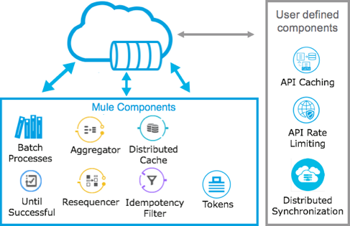

**Runtime Manager** to deploy and manage all of your Mule applications from one central location, whether your apps are running in the cloud, on-premises, or on Runtime Fabric.

**Anypoint Visualizer** displays views of different aspects of an application network graph.